- Install Jenkins and run Jenkins on port number 8081.
Step 1: Launch an instance and connect to it.
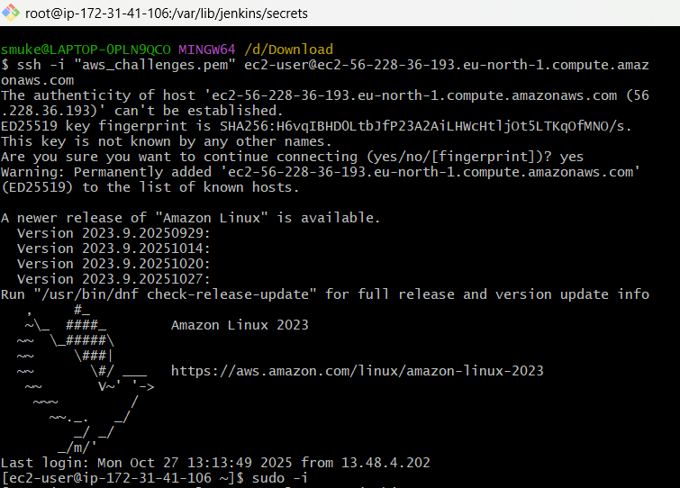
Step 2: Goto official Jenkins website and select Red Hat and run the commands in EC2 instance
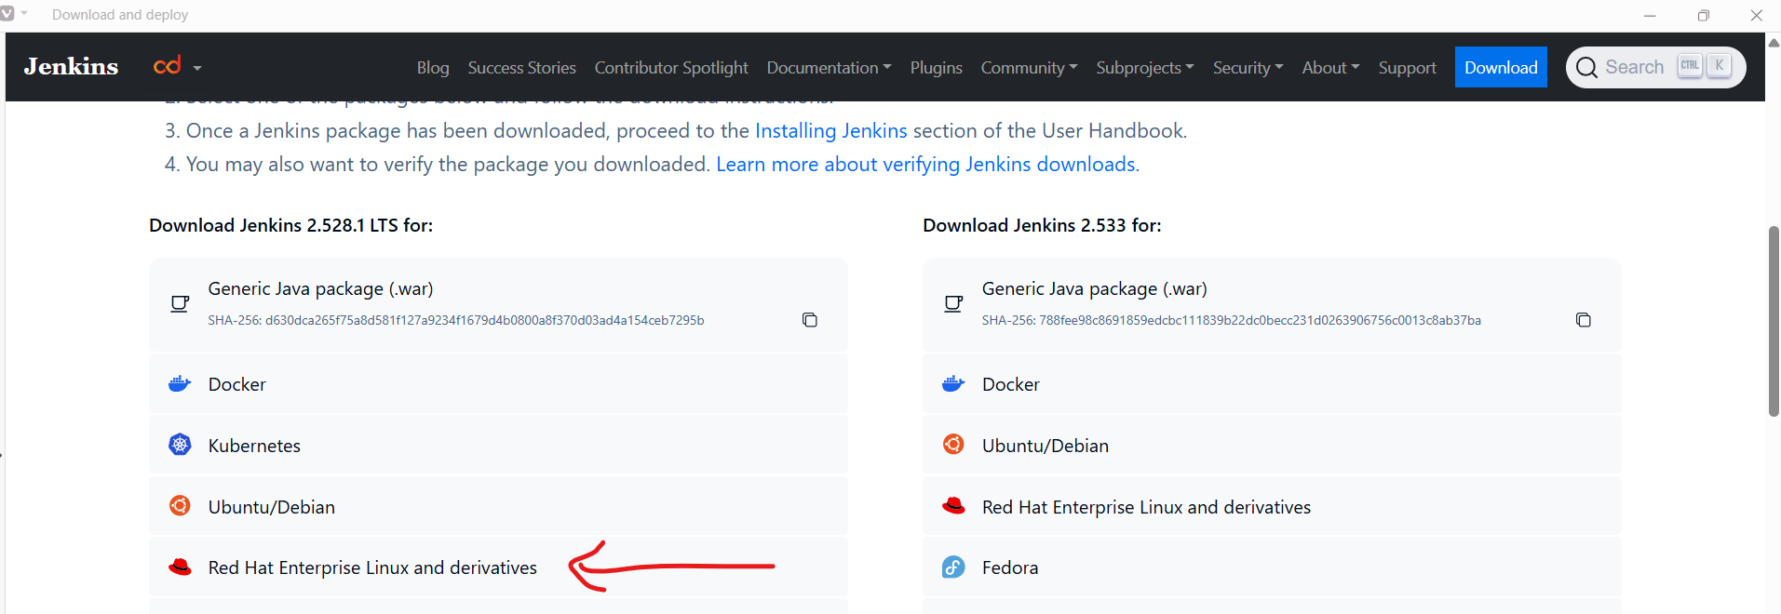
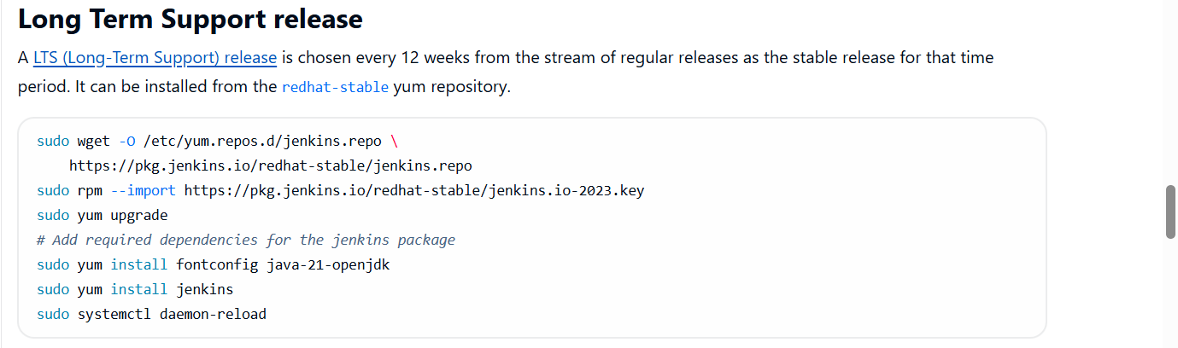
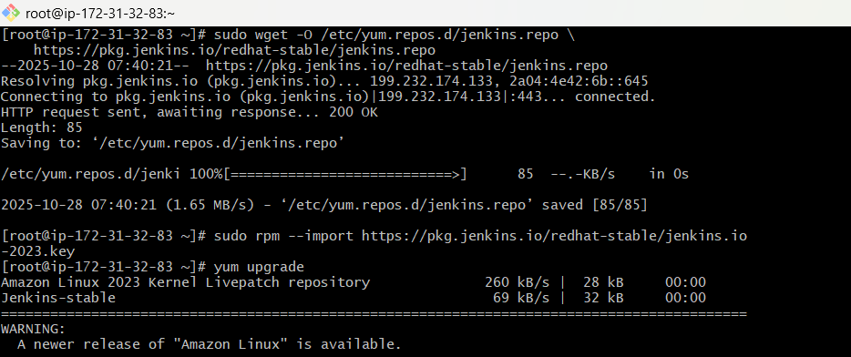
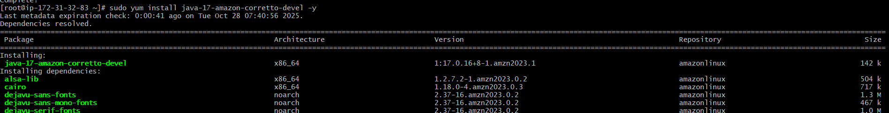
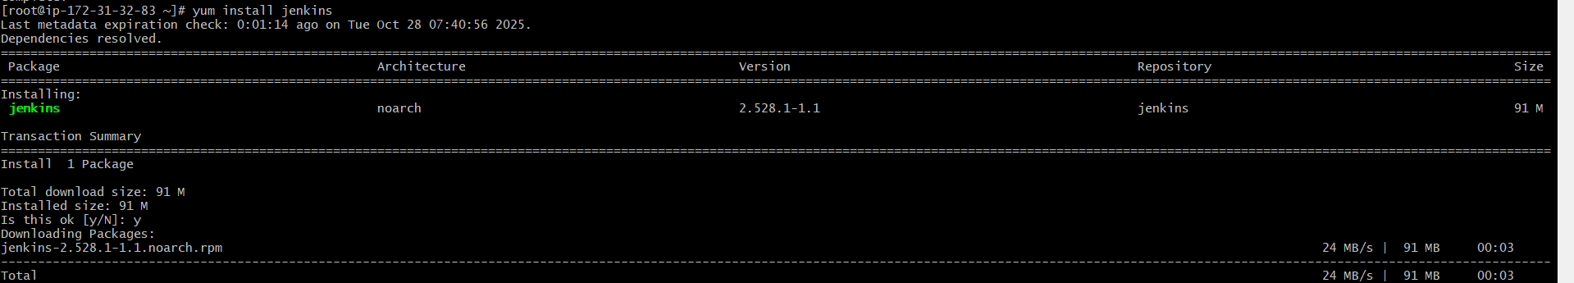
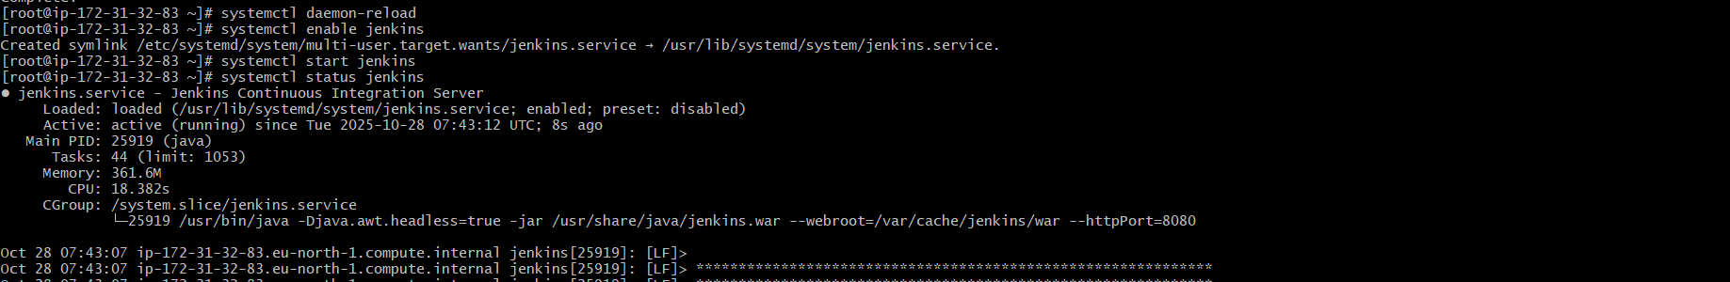
Step 3: Now open Jenkins.service file and change the port to 8081 and restart Jenkins.
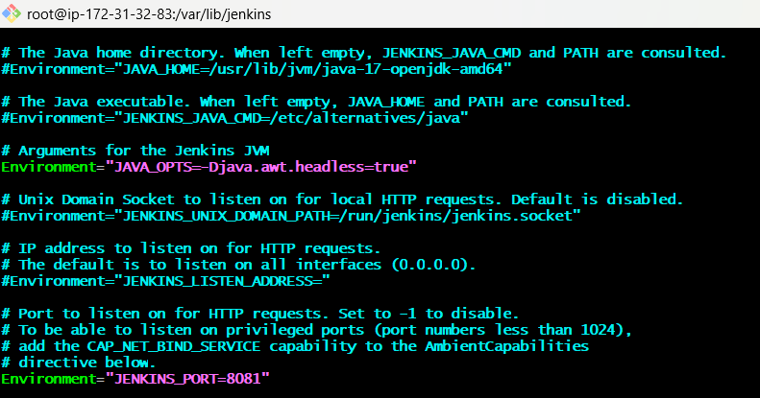
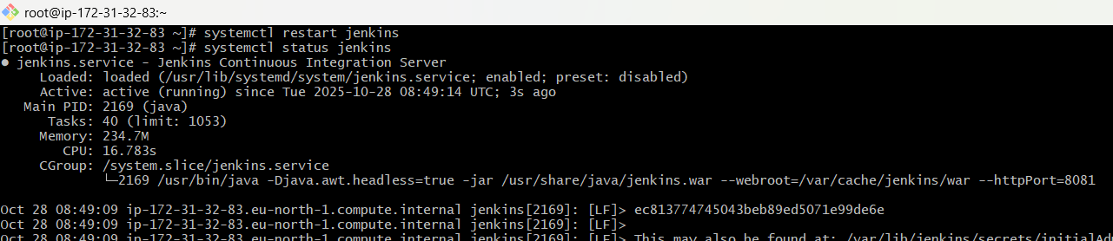
Step 4: Run public_ip:8081 in the browser.
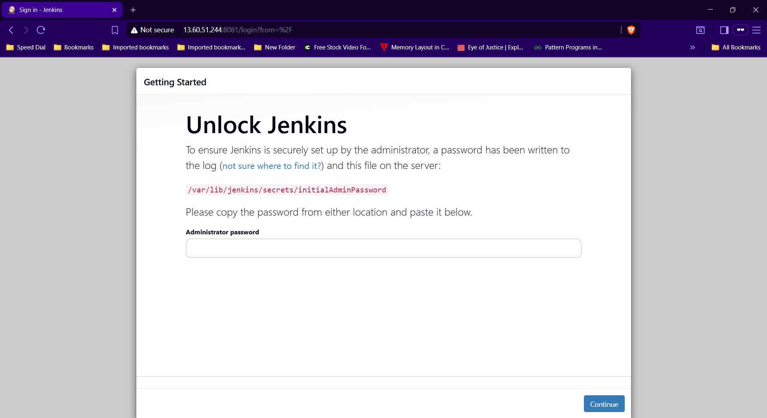

- Secure Jenkins server.
Step 1: Run cat /var/lib/jenkins/secrets/initialAdminPassword, copy and enter the password in Jenkins login page.
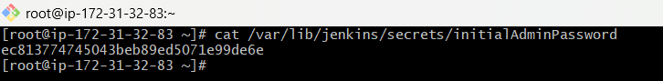
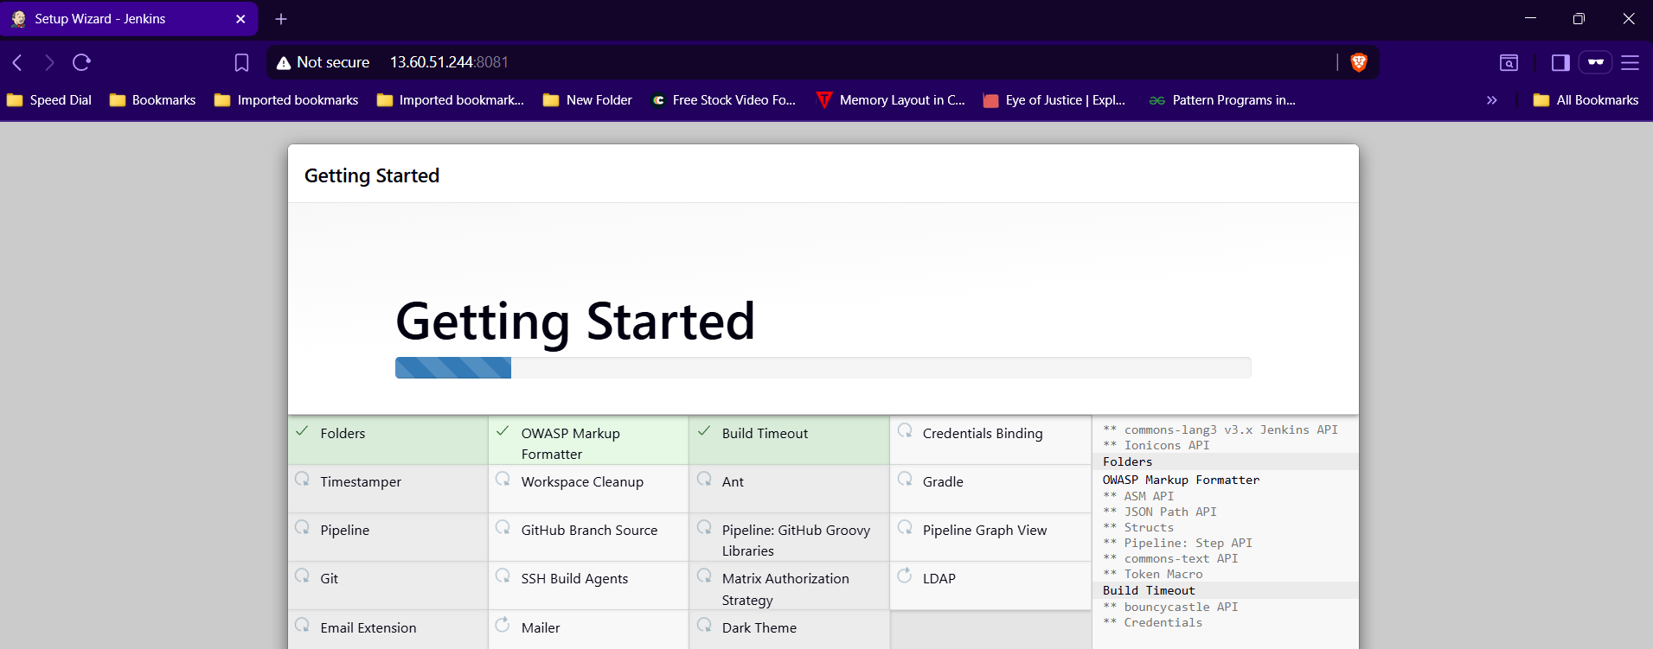
Step 2:Goto security and change the password.
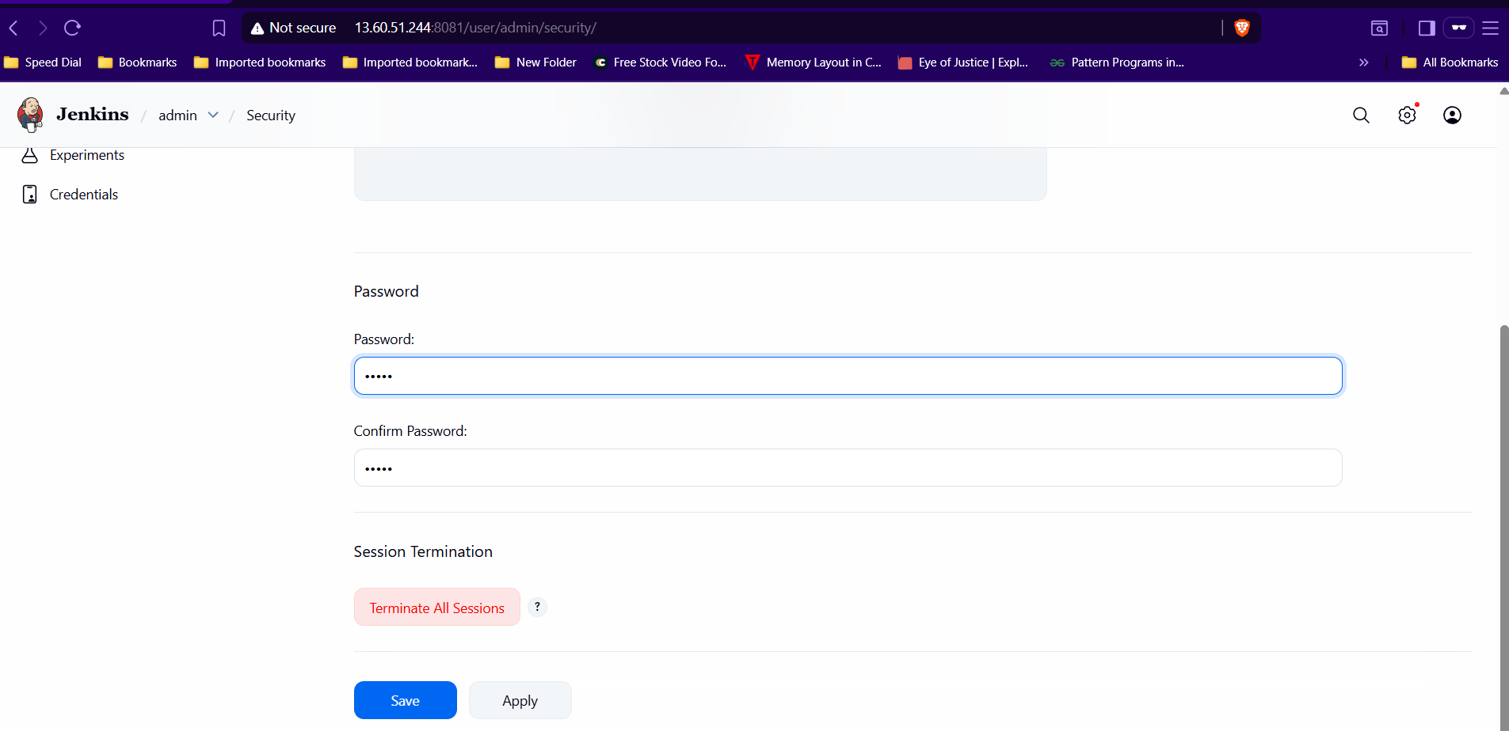
Step 3: Now delete InitialAdminPassword file.

- Create users called DevOps, Testing in Jenkins with Limited access.
Step 1: Goto Manage JenkinsUserCreate userEnter detailscreate.
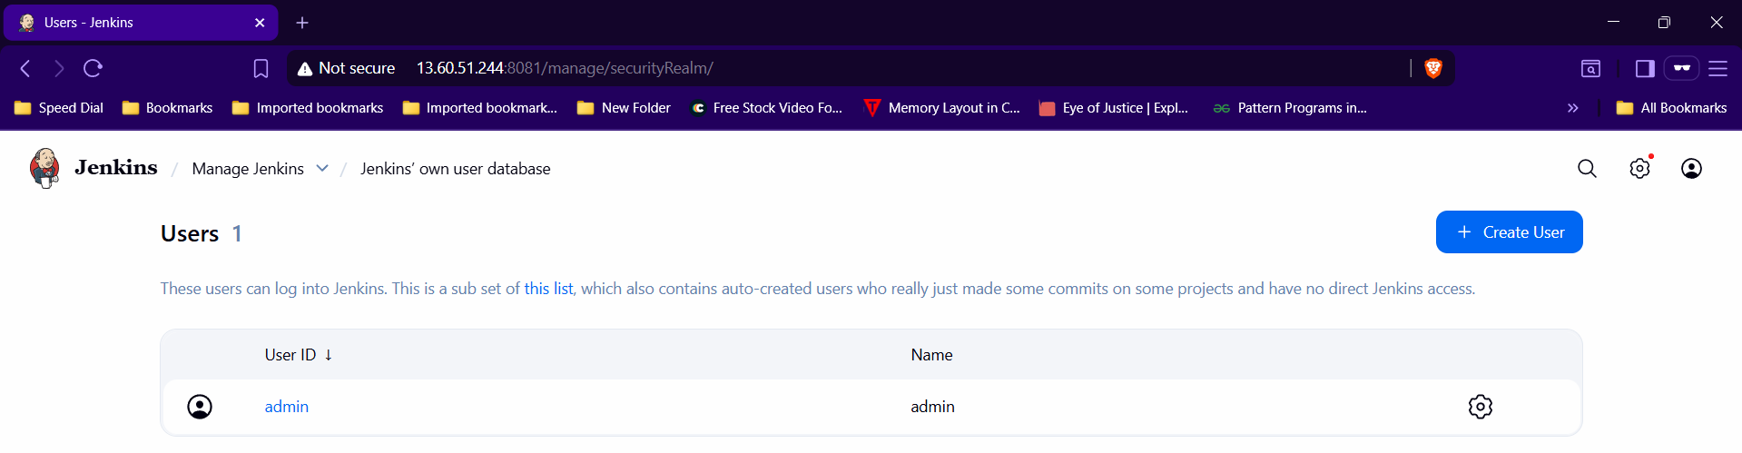

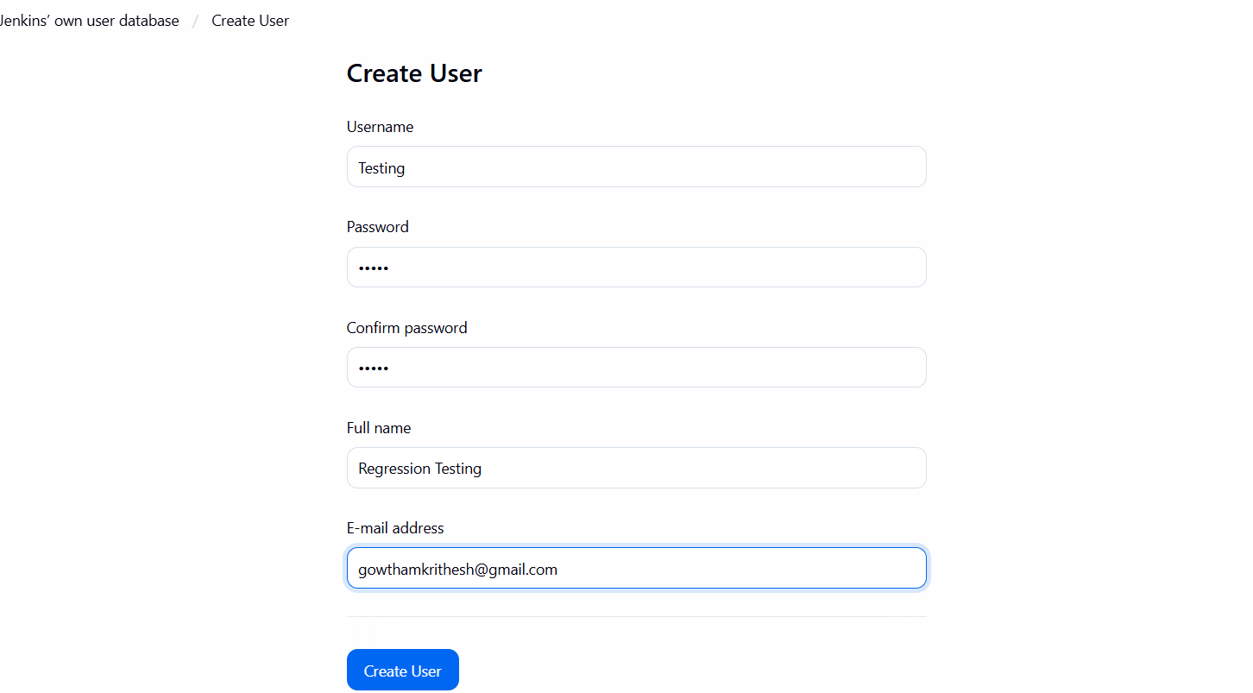
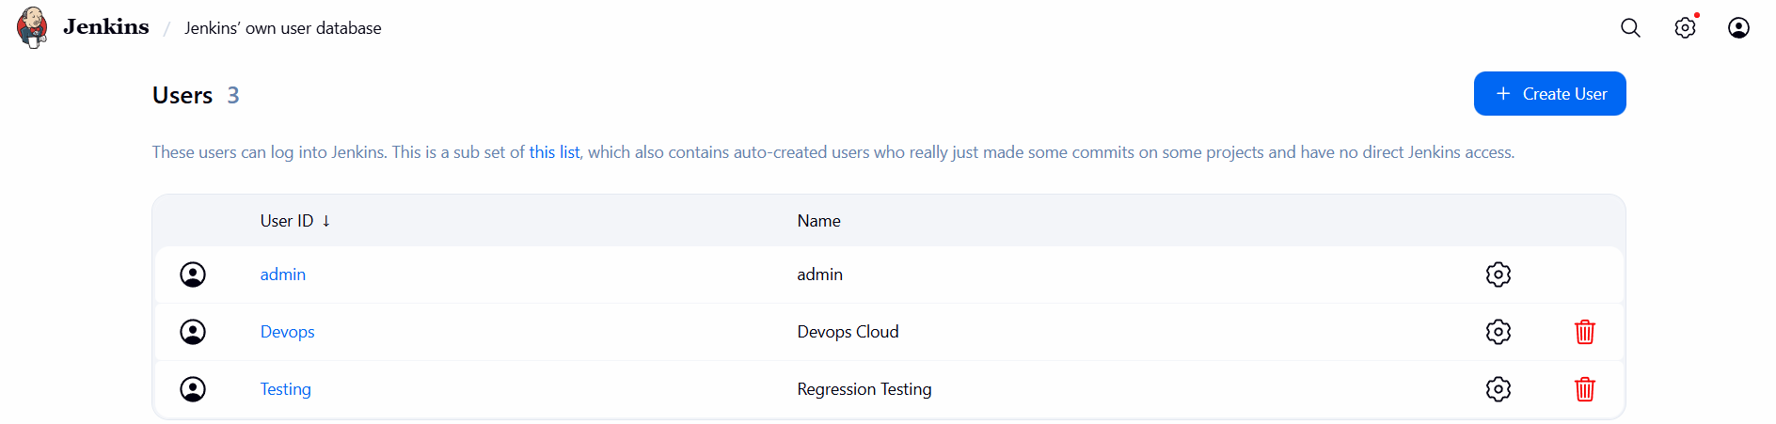
Step 2: Goto Manage Jenkinssecurityselect “Project-based matrix Authorization strategy” under Authorization option and add usersapply & save.
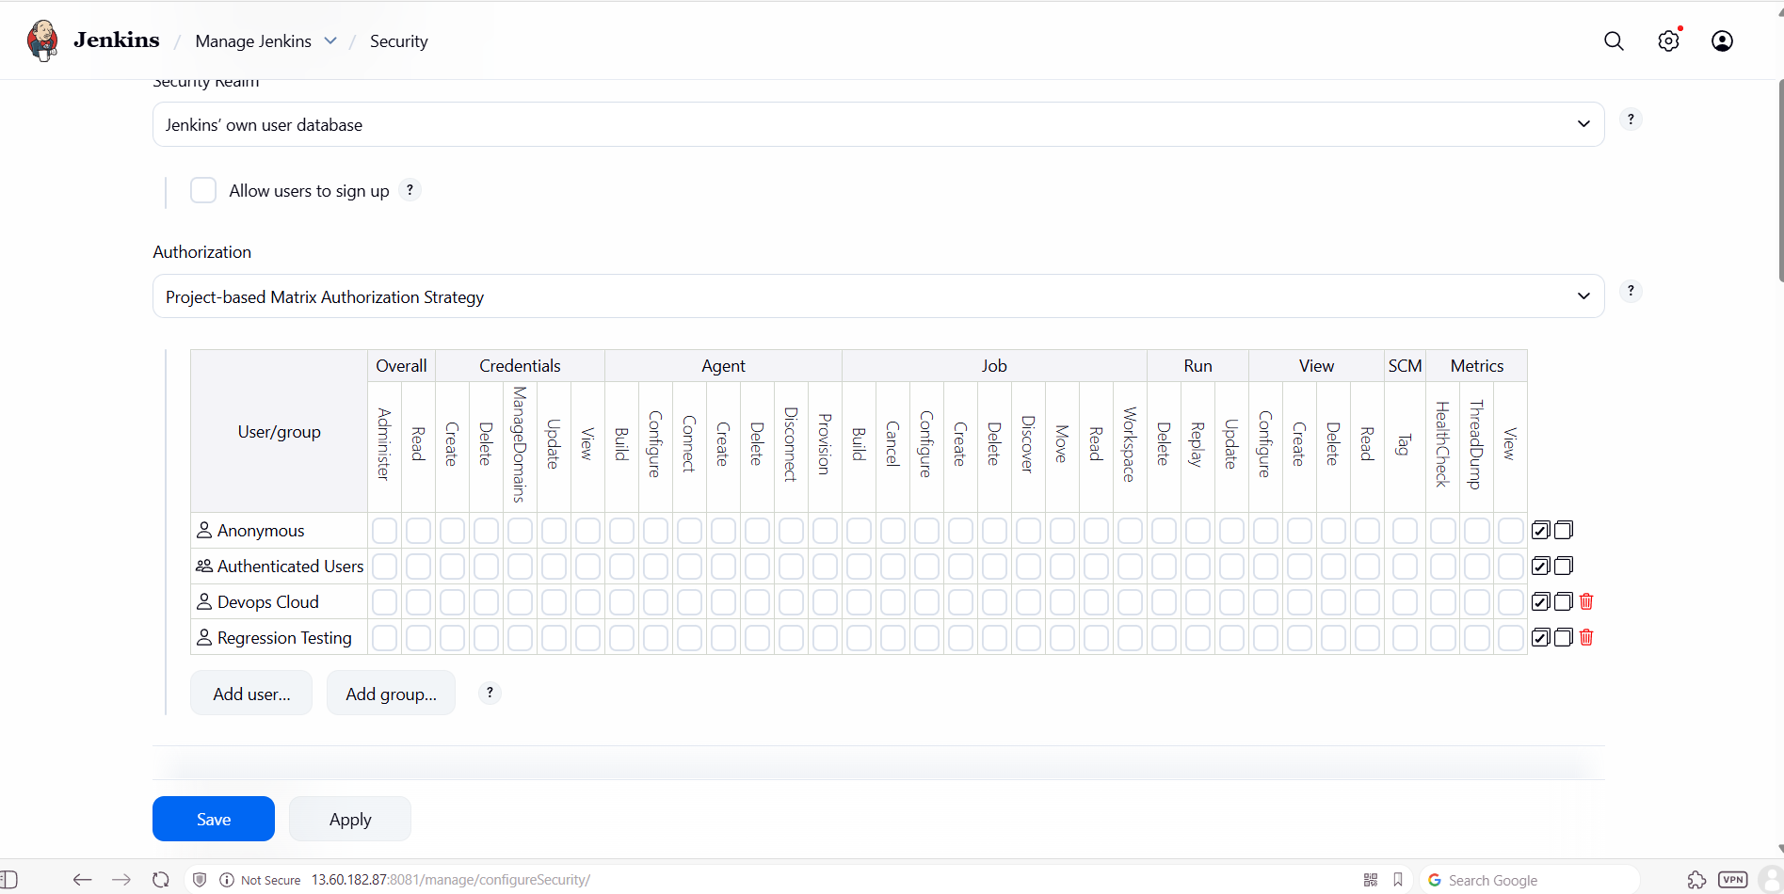

- Configure labels and restrict the jobs to execute based on label only.
Step 1: Goto Manage Jenkinssystemgive “master” as label name apply & save.
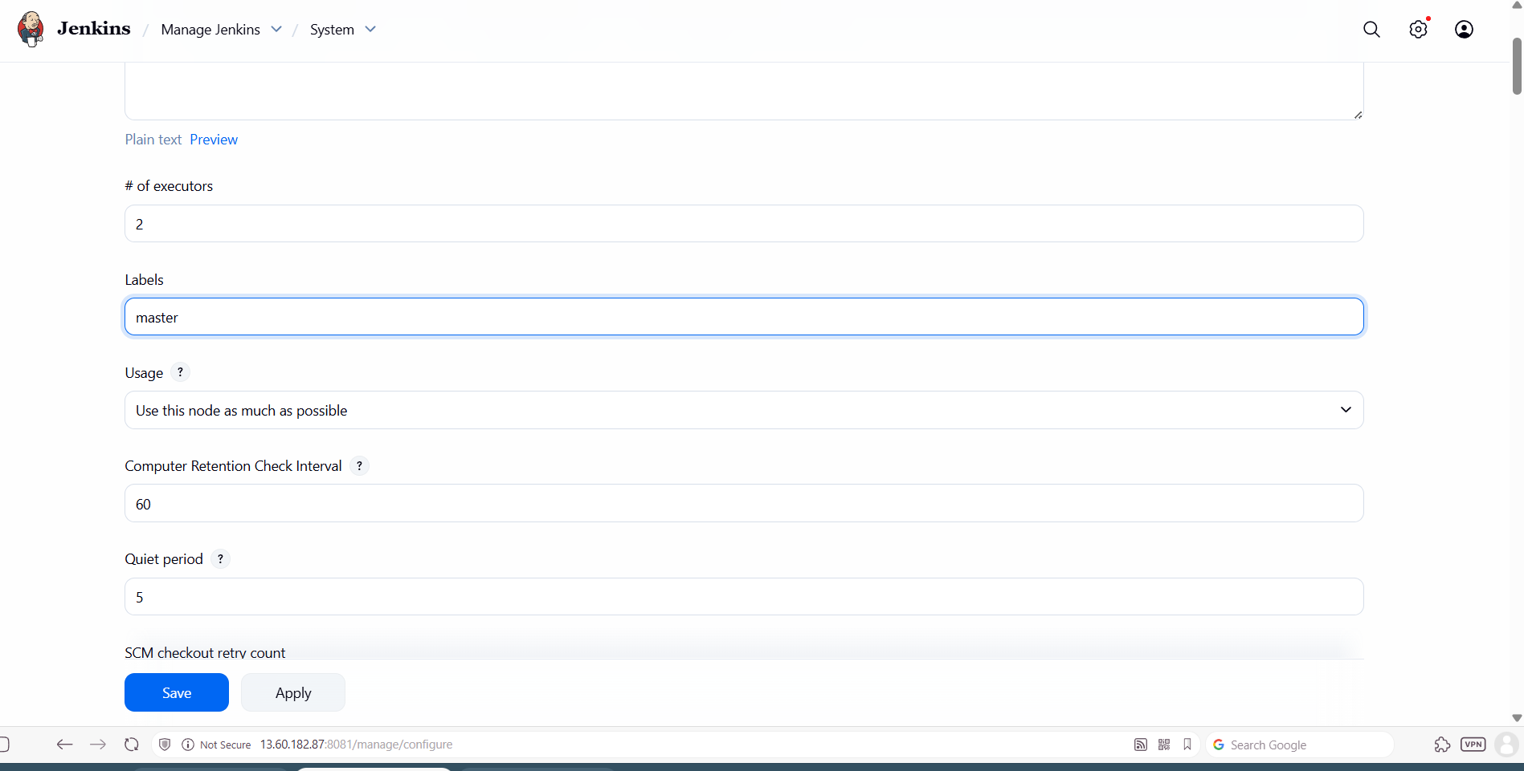
Step 2: Goto Manage JenkinspluginsAvailable pluginsselect Node and label parameter and install it.
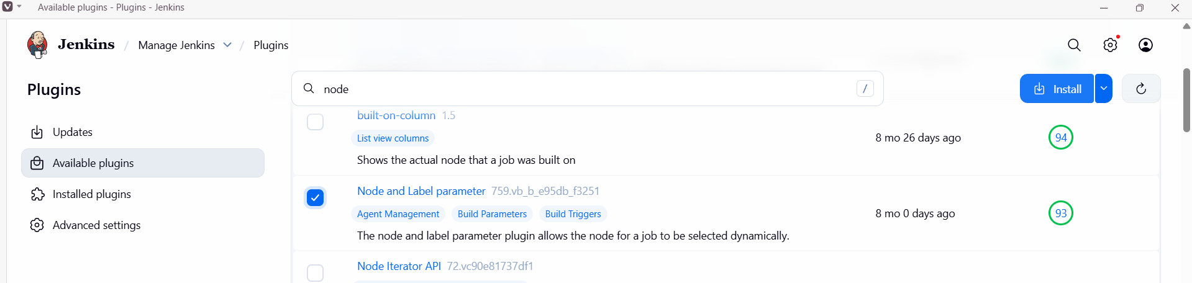
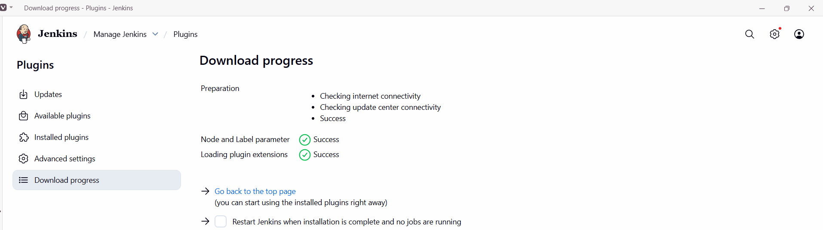
Step 3: Select a job and select label expression and save it.
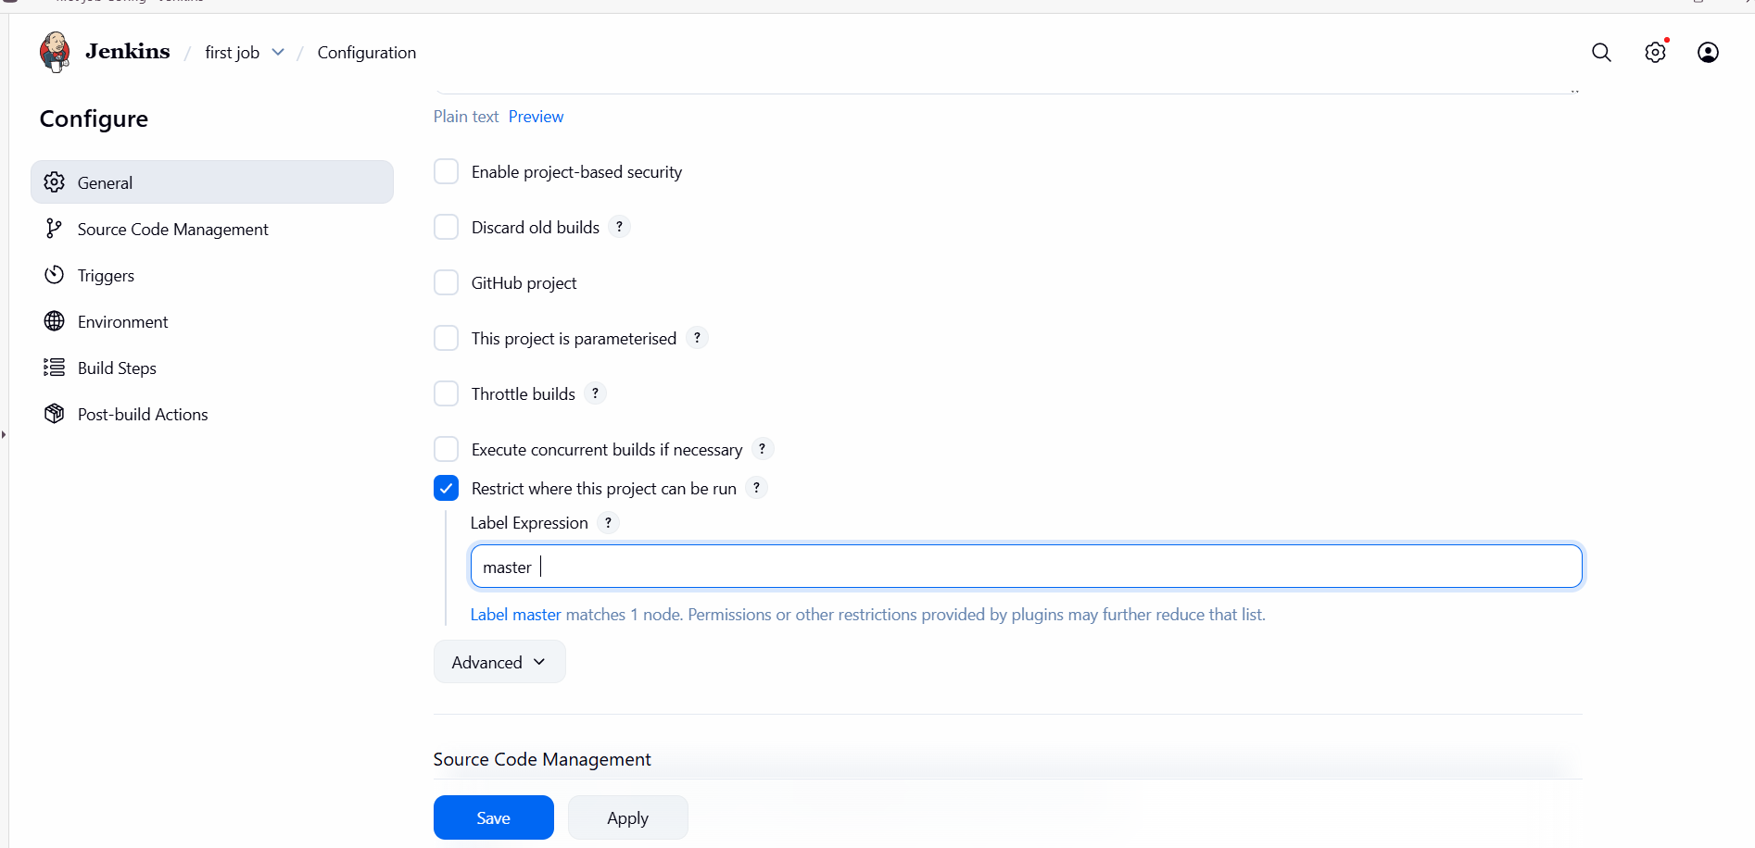

- Create Three sample jobs using the below URL. https://github.com/betawins/Techie_horizon_Login_app.git
Step 1: Install git in EC2 instance.
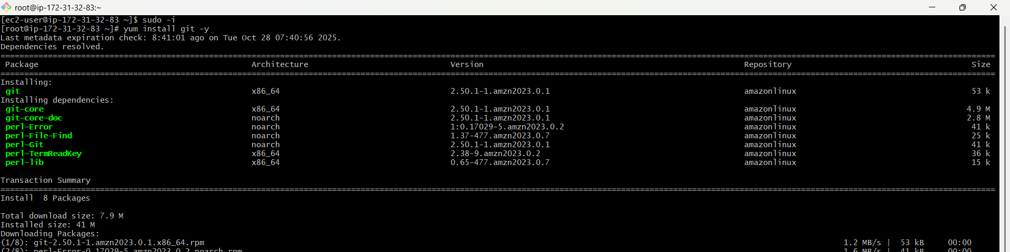
Step 2: Create a jobgive descriptionselect Git and paste repo linkapply&save.
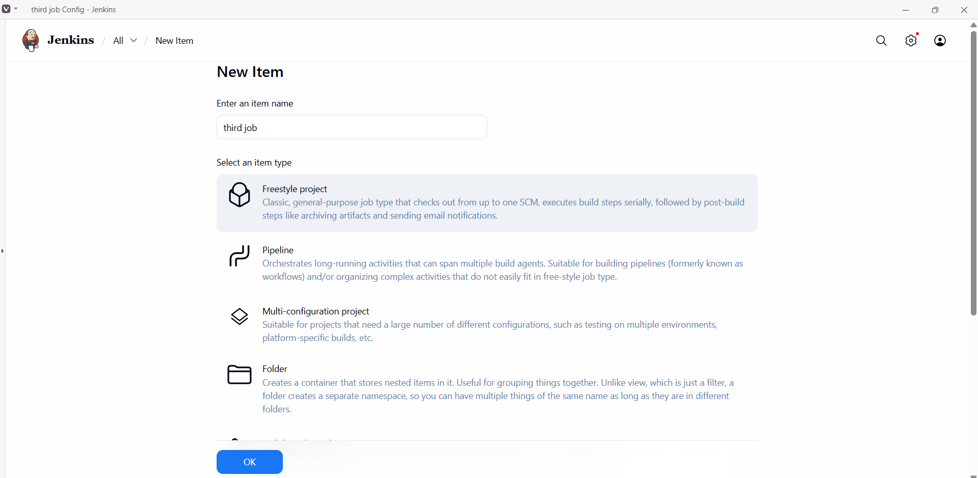
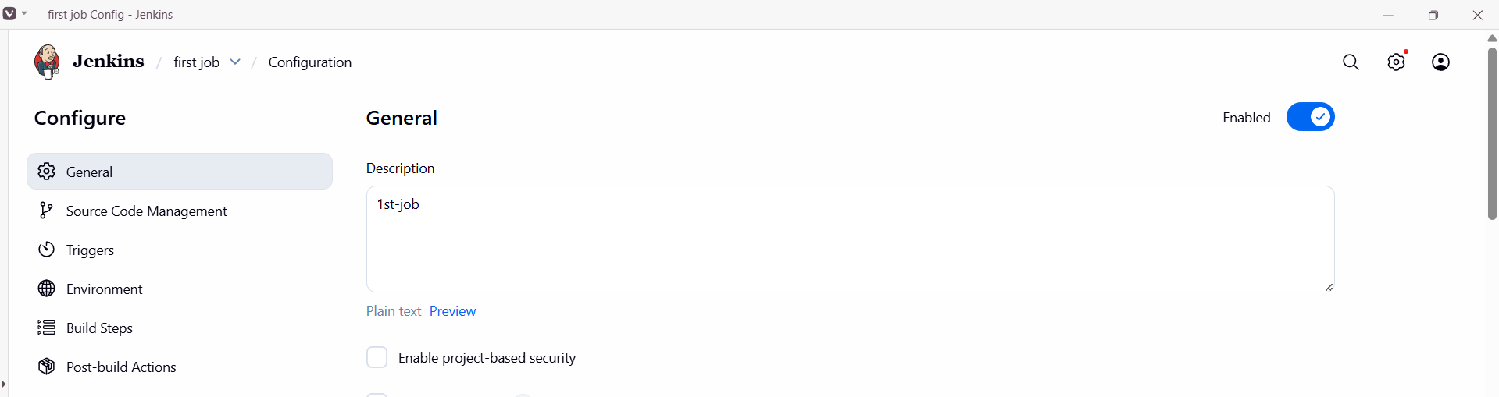
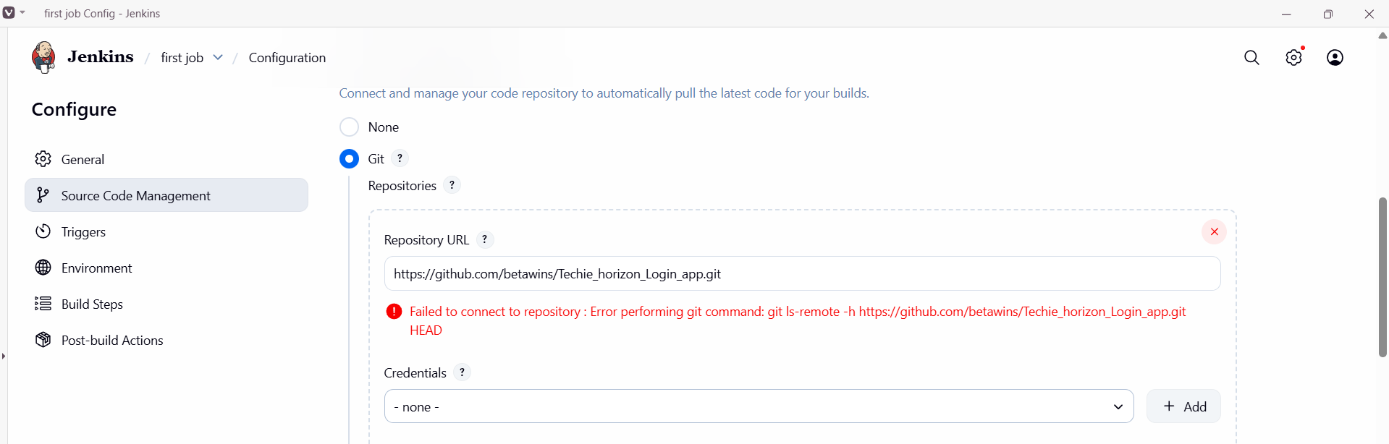

Step 3: Select Build now to run the job.
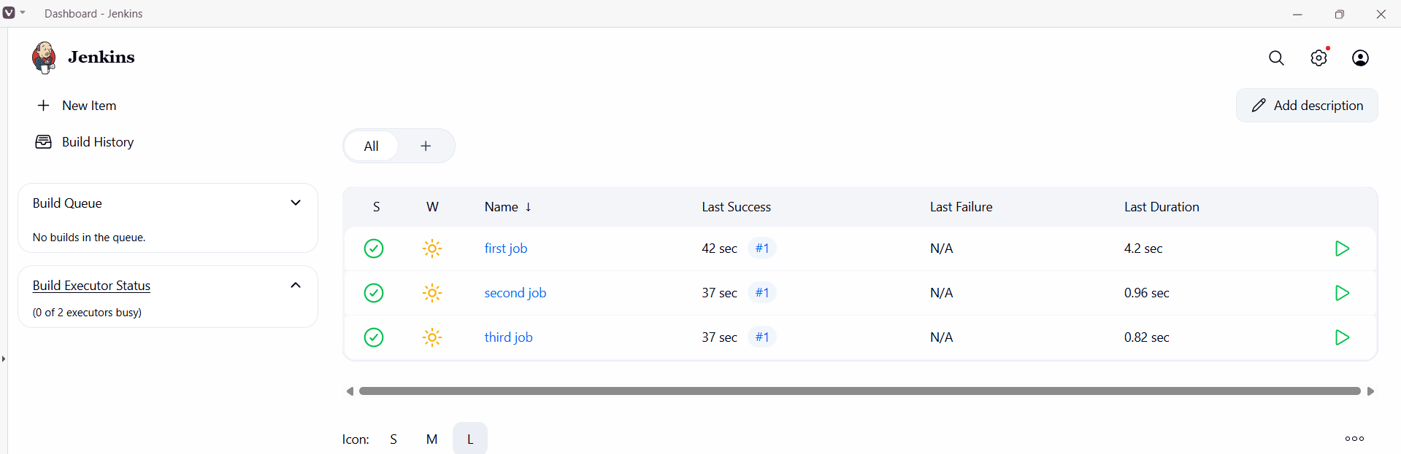

Repeat the same process to create remaining jobs.

- Create one Jenkins job using git hub Private repository.
Step 1: Goto GitHubsettingsDeveloper SettingsPersonal access tokensTokens(classic) Generate new token
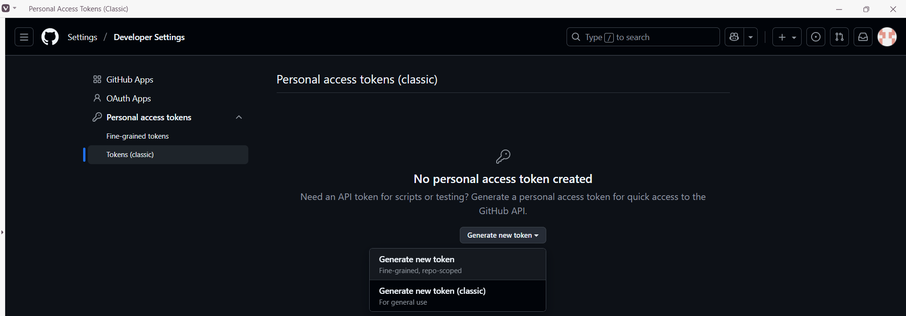
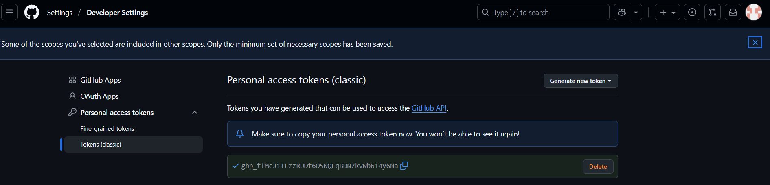
Step 2: Now Goto Jenkinsmanage JenkinscredentialsglobalAdd credentials.
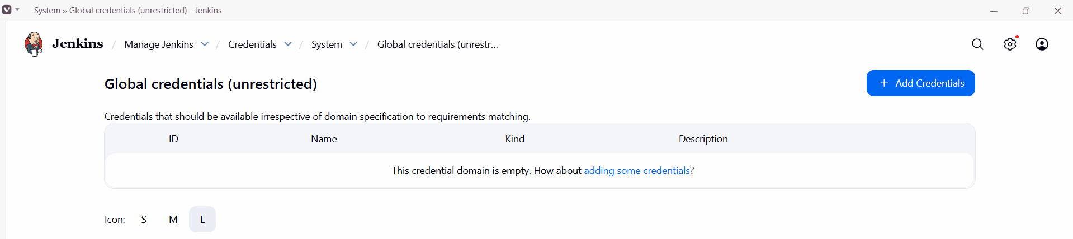

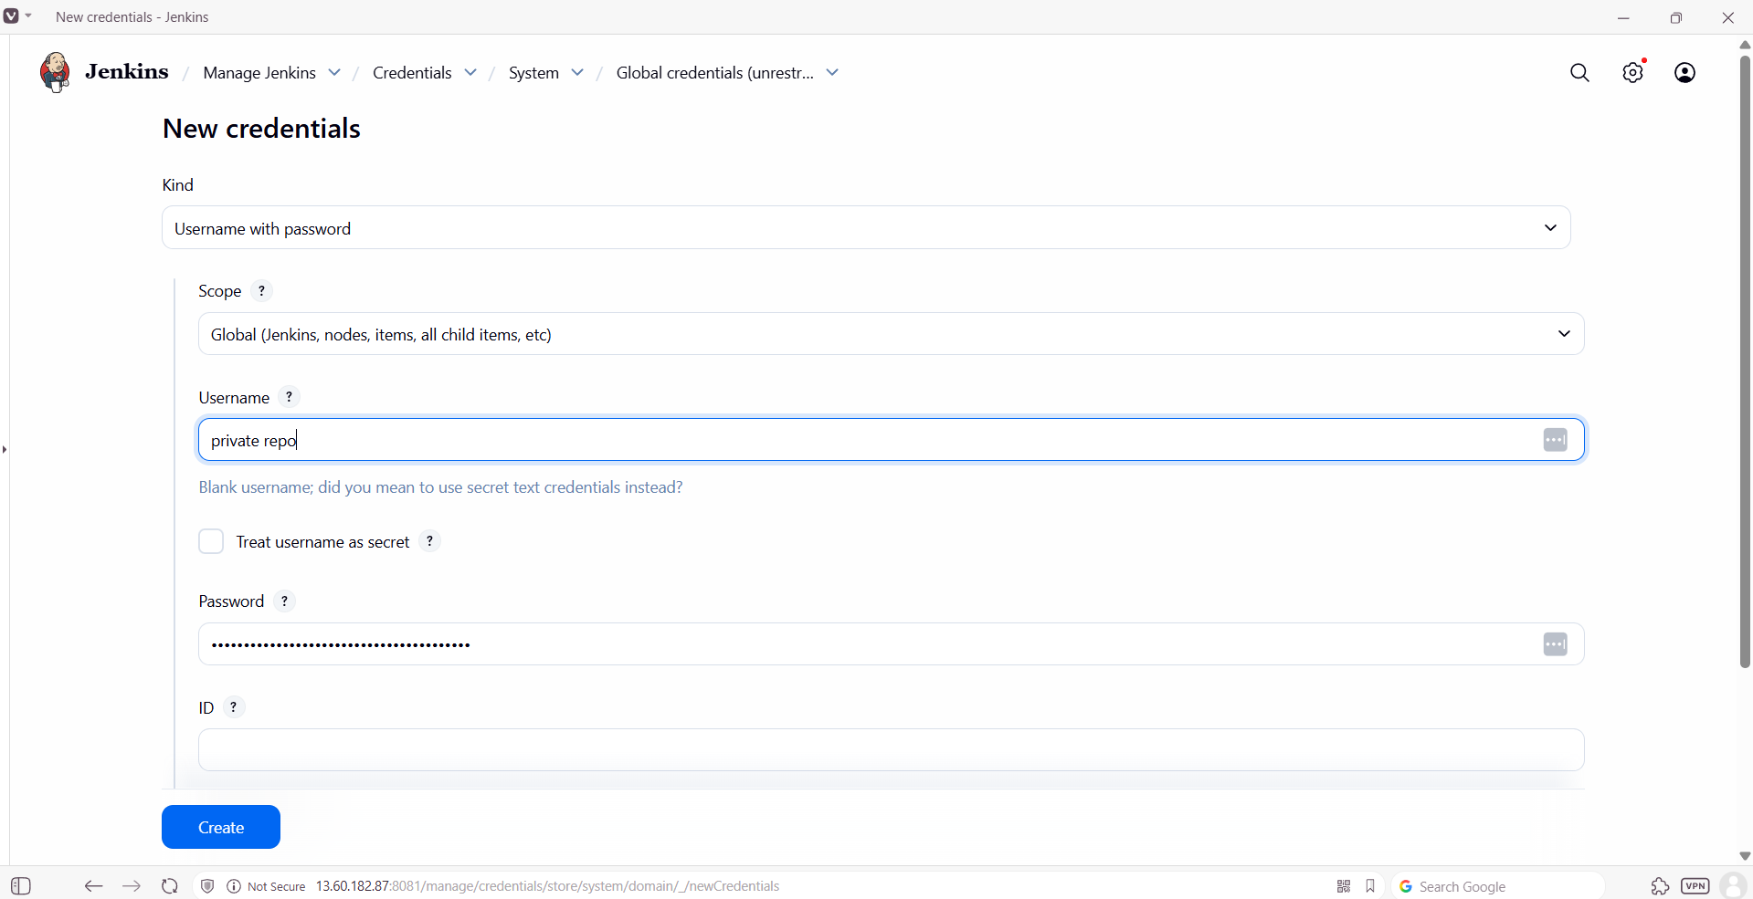
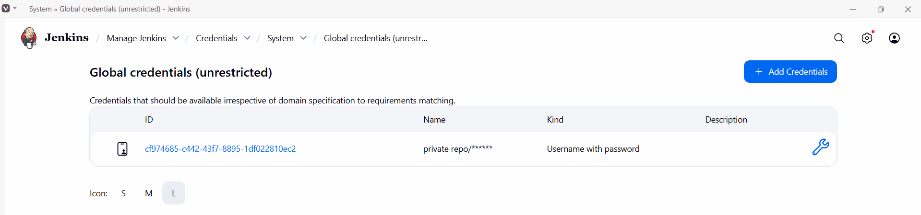
Step 3: copy link of private repo and create a job.
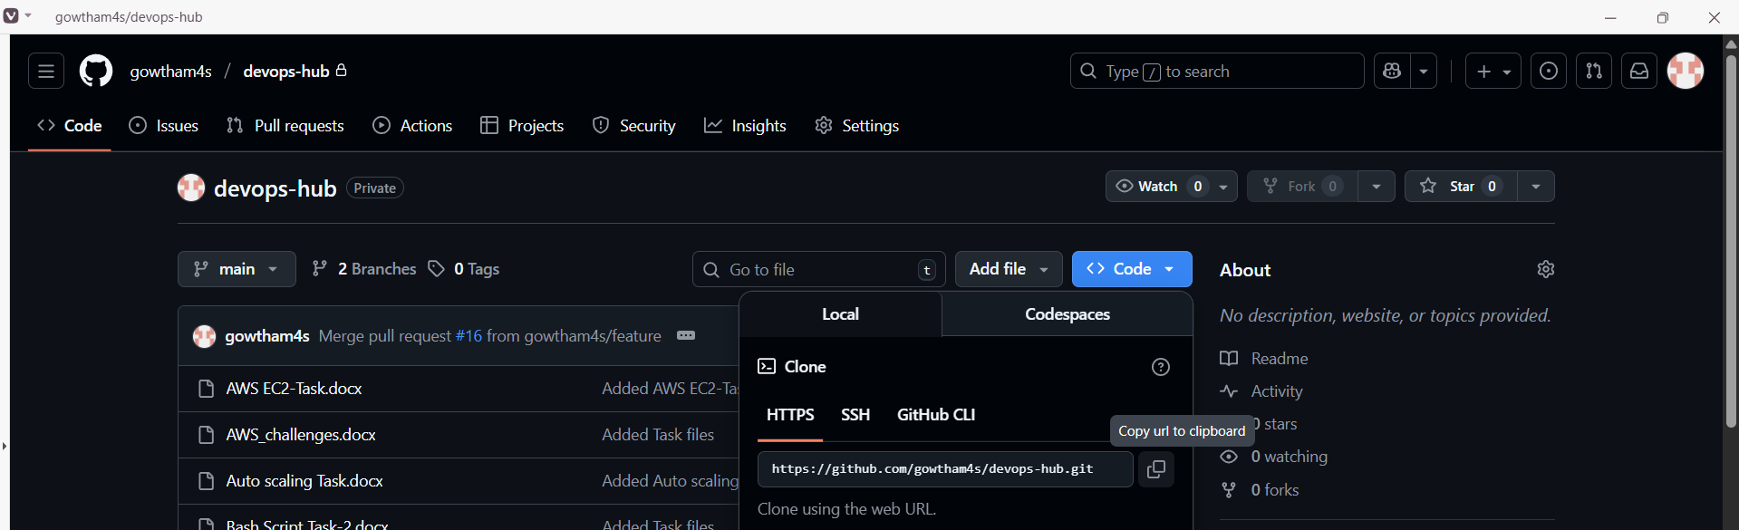
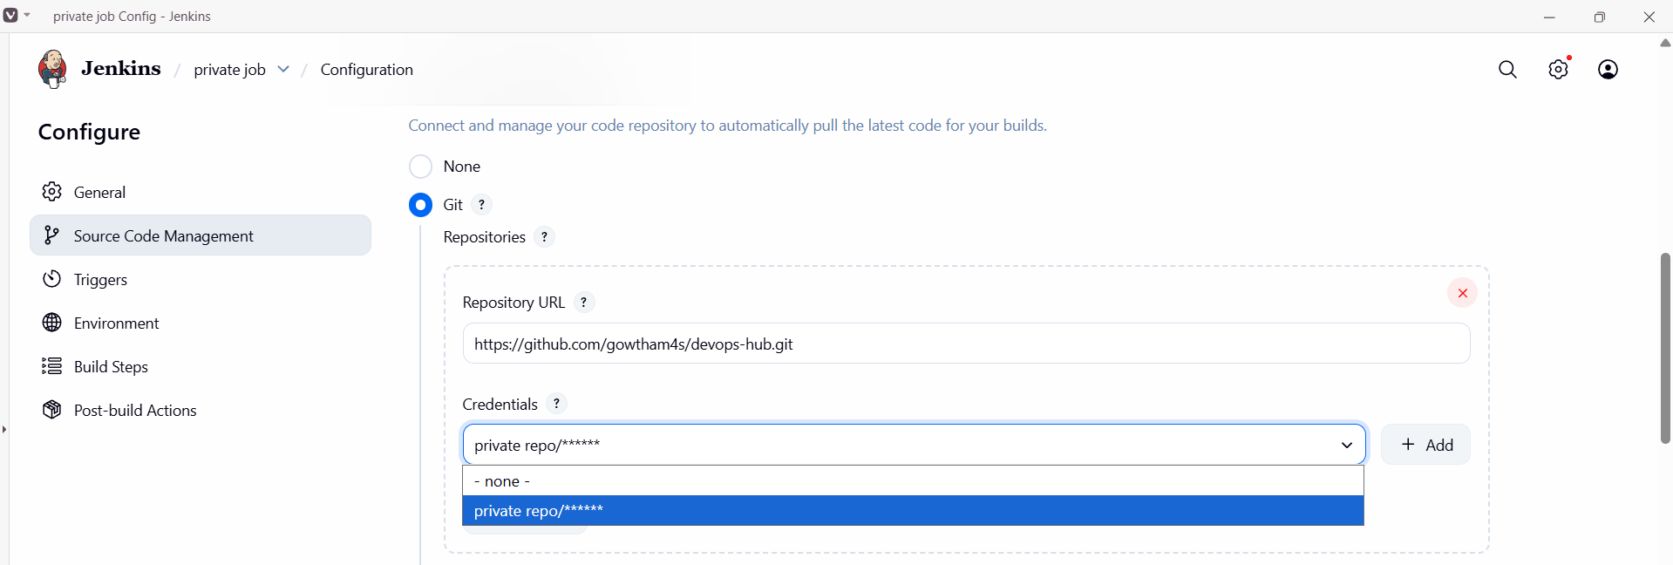
Step 4: Select Build Now to run the job.
